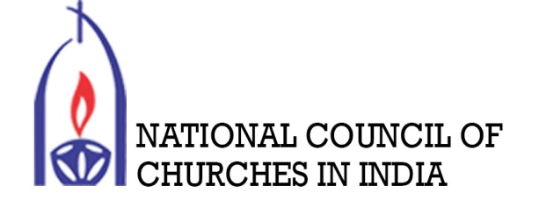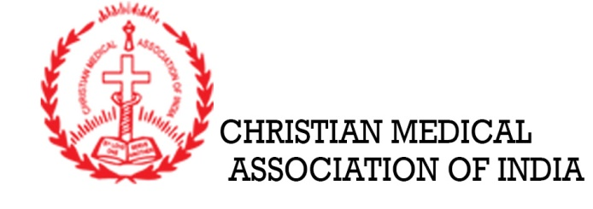
Webinar on
Rebooting Ekklesia Series:
Youth and Mental Health in the Context of COVID-19
National Council of Churches in India – Youth Concerns
Christian Medical Association of India
13th June 2020 (Saturday) 5:00 pm

CONCEPT NOTE

Introduction
In January 2020 the World Health Organization (WHO) declared the outbreak of a new coronavirus disease, COVID-19, to be a Public Health Emergency of International Concern. Subsequently in March 2020, the WHO made the assessment that COVID-19 can be characterized as a pandemic. Ever since, the outbreak of COVID-19 throughout the world has caused public panic and mental health stress, with an increasing number of cases being diagnosed and public concerns about infection. The ripples of this pandemic have spread out affecting the public and individuals resulting with interconnected effects on the socio-economic, mental, and physical wellbeing. The society, particularly the young people into experience psychological problems such as post-traumatic stress disorder, psychological distress, depression, anxiety, and even death due to loss of jobs, failure of business, disturbance of education (even to the loss of academic year), loss of family members, social lockdown and the restrictions that affect their way of ‘normal’ day to day life.
In India, 65% of the population is less than the age of 35 years and 50% below 25 years of age. These young people are the backbone of the country and at this moment in time of pandemic many of them are undergoing mental breakdown. The social and economic fissures exposed by the pandemic have already caused in unemployment, depleted social safety nets, starvation, among other things among the young people. This post-COVID landscape becomes a fertile breeding ground for an increase in chronic stress, anxiety, depression, alcohol dependence, and self-harm in which the young people have fallen victim.
The Church, Church-based organizations and the faith community as a whole have a great role in rebuilding the holistic wellbeing of the society and individual particularly the young people in both clinical/scientific approach and pastoral care. We will reconnoitre the means and ways from the resource persons during the webinar.
Aim and Objective
The webinar aims:
- To explore the factors affecting the mental health of youth groups and provides recommendations and means of intervention, both clinical and pastoral care by the church and Church related organizations in India, in the mental health of youth groups – students and working young people.
- To bring awareness and training to the youth leaders of the church and health sectors who are engaging among the young people.
- To identify the symptoms of mental health breakdown due to COVID-19.
- To further help and counsel the young people who are undergoing and/or intervene to those who are showing symptoms of mental health breakdown.
- To extend and exercise the role of the Church and health related agencies in restoring the lives of the young people.
Target Groups
The primary target group of the webinar is to the young people who are undergoing and/or on the verge of having mental breakdown; youth leaders in the church and/or related mental health organizations who are working among the young people; counsellors of an institution who are engaging with students and young working people.
Resource Persons:
Dr. Kimneihat Vaiphei
Asst. Professor,
Department of Psychiatric Social Work
NIMHANS, Bangalore
Rev. Dr. Israel David
Asst. Professor,
Department of Christian Ministry
Union Biblical Seminary, Pune
Medium of Communication:
The medium of communication for the webinar is in English.

Prepared by:
Jianthaolung Gonmei Imtimenla Aier
Executive Secretary – Youth Concerns Secretary – Chaplain Section
National Council of Churches in India Christian Medical Association of India

