Global Day of Prayer to End Famine
Sunday, 21 May 2017

This service of common prayer has been prepared by the
World Council of Churches (WCC) -Ecumenical Advocacy Alliance- Food for Life Campaign

[Please stand, as you are able]

Opening Responses

Leader: Glory to you, our God, glory to you.

Psalm 24

Leader: The earth is the Lord’s and all that is in it,
the world, and those who live in it;
All: For God has founded it on the seas,
and established it on the rivers.

Leader: Who shall ascend the hill of the Lord?
And who shall stand in God’s holy place?
All: Those who have clean hands and pure hearts,
who do not lift up their souls to what is false,
and do not swear deceitfully.

Leader: They will receive blessing from the Lord,
and vindication from the God of their salvation.
All: Such is the company of those who seek the Lord,
who seek the face of the God of Jacob.

Leader: Lift up your heads, O gates!
All: Be lifted up, O ancient doors!
That the Glorious Lord may come in.
Leader: Heavenly Lord, Comforter;
We come to you, hungry and thirsty for righteousness.

All: Come and dwell in us.
Satisfy us so that we might offer
hospitality, food and rest
to the hungry and weary.

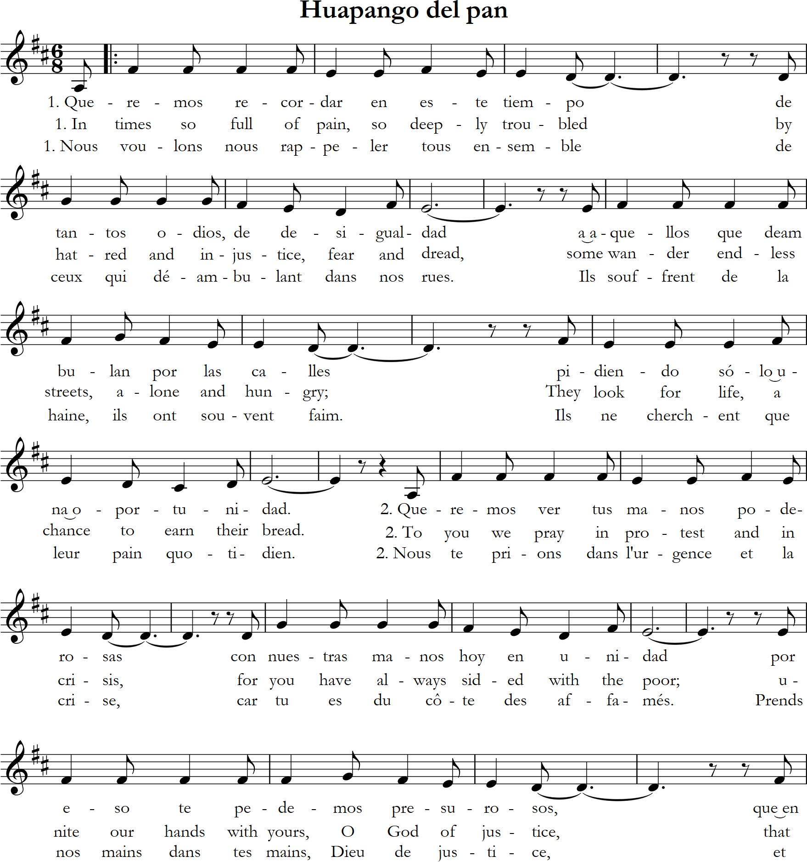
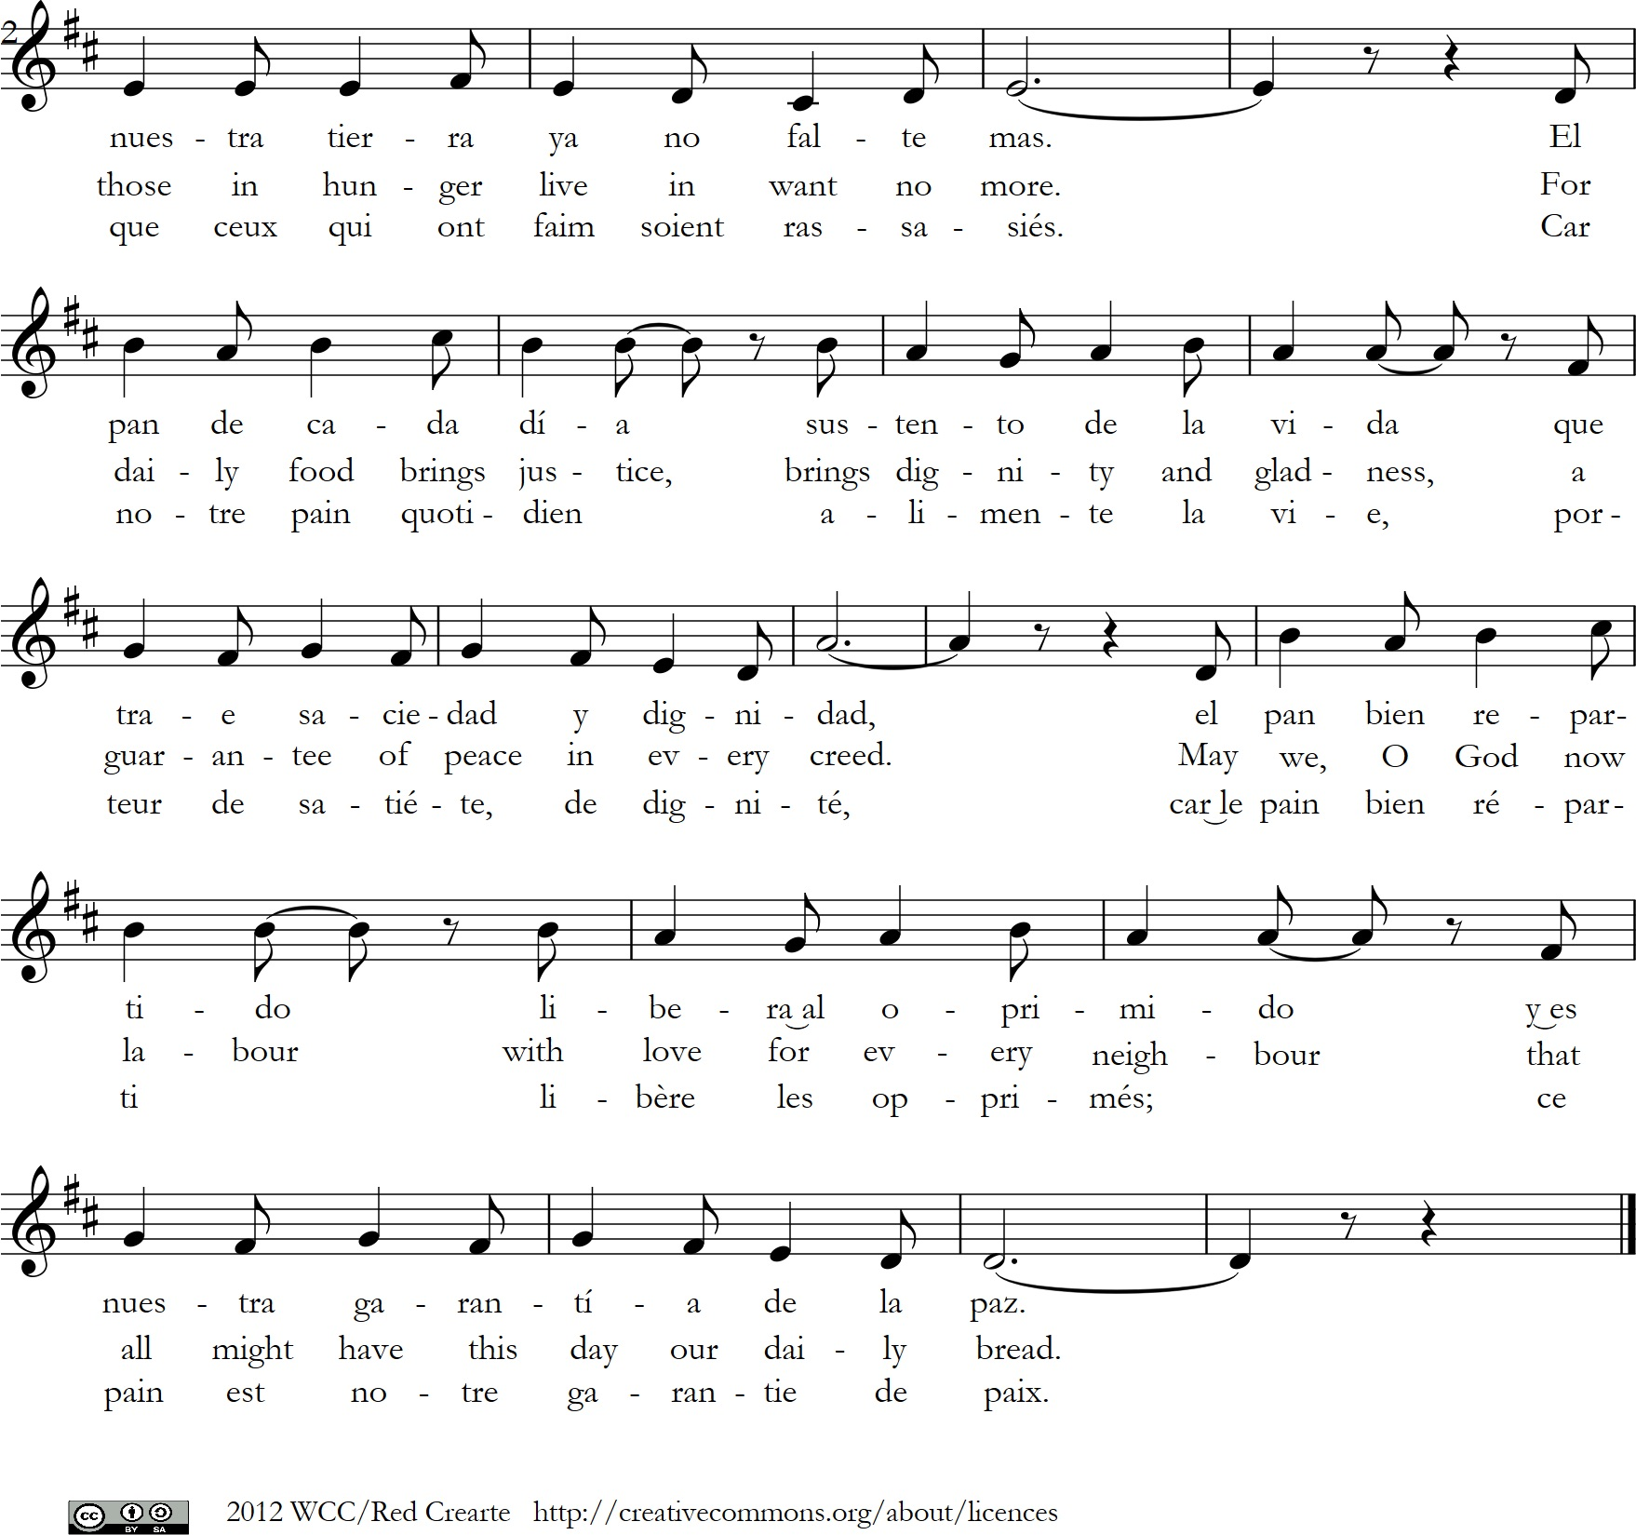

[Please be seated]

.

Confession

God of life,
you commanded us to be the caretakers of your creation.
Instead, because of our self-centeredness,
we have exploited and destroyed it.
Ju yeon, yong seo ha so seo. (Korean)
Lord, forgive us.

God of justice,
you commanded us to care for the life of your creatures.
Instead, because of our greed,
we accumulate resources for our own benefits
and perpetuate the ecological debts in the world.
Parameshwar, hame ksama karo. (Hindi)
Lord, forgive us.

God, the Bread of life,
you commanded us to feed the hungry
and gave us sufficient food for every creature.
Instead, because of our gluttony
we forget the needs of others,
take more than we need and waste the food.
Ya Rab, ighfer lana. (Arabic)
Lord, forgive us.

God of compassion,
you commanded us to love each other as you love us.
Instead, because of our love of profits,
we foster unsustainable consumption
and deny others the means to live in fullness of life.
Kami yo, yurushite kudasai. (Japanese)
Lord, forgive us.

God of freedom,
you commanded us to forgive.
Instead, because of our iniquities,
we fail to forgive our enemies
and redeem the debts of others
Herre, tilgiv os. (Danish)
Lord, forgive us.

God of peace,
you commanded us to live in peace.
Instead, because of our love of power
we control others, spread hatred, and choose war.
Mwari tiregerereiwo. (Shona)
Lord, forgive us.

Gracious God,
hear our confessions, forgive,
and have mercy on us.
Amen.

Note: other available languages may be substituted.
Music and liturgy resource workshop, Seoul, Korea, July 2012.
Text by Ester Widiasih, Fedric Anilkumar, Susanne Gölz
World Council of Churches.

[Please stand, as you are able)

Word of Assurance - Isaiah 41: 13, 17- 20

For I, the Lord your God,
hold your right hand;
it is I who say to you, “Do not fear,
I will help you.”
When the poor and needy seek water,
and there is none,
and their tongue is parched with thirst,
I the Lord will answer them,
I the God of Israel will not forsake them.
I will open rivers on the bare heights,
and fountains in the midst of the valleys;
I will make the wilderness a pool of water,
and the dry land springs of water.
I will put in the wilderness the cedar,
the acacia, the myrtle, and the olive;
I will set in the desert the cypress,
the plane and the pine together,
so that all may see and know,
all may consider and understand,
that the hand of the Lord has done this,
the Holy One of Israel has created it

Appropriate Hymn

Gospel Reading: Matthew 25: 34 - 40

Then the king will say to those at his right hand, ‘Come, you that are blessed by my Father, inherit the kingdom prepared for you from the foundation of the world; for I was hungry and you gave me food, I was thirsty and you gave me something to drink, I was a stranger and you welcomed me, I was naked and you gave me clothing, I was sick and you took care of me, I was in prison and you visited me.’ Then the righteous will answer him, ‘Lord, when was it that we saw you hungry and gave you food, or thirsty and gave you something to drink? And when was it that we saw you a stranger and welcomed you, or naked and gave you clothing? And when was it that we saw you sick or in prison and visited you?’ And the king will answer them, ‘Truly I tell you, just as you did it to one of the least of these who are members of my family, you did it to me.’

[Please be seated]

Responsive Prayer

Leader: We especially pray for the countries affected by famine or which are on the brink of being declared as being famine affected.

All: We pray for the people, churches, wider society and the governments of South Sudan, Somalia, Nigeria and Yemen. We also pray for all the neighbouring countries, which are also affected and are receiving and hosting millions of displaced people.

Leader: Lord, we know that food is more than a human right; it is a divine gift that cannot be impeded.

All: We pray and do all that we can to ensure the more than 20 million people are at risk of starvation are moved away from the precipice of famine!

Leader: Lord, we acknowledge that hunger crises are preventable. Help us to reflect, act, and move together.

All: We pray for the strengthening of the prophetic voice of the churches.
We also pray for the ministry of accompanying individuals and communities with their preferential attention and ministry to the marginalised and the poor.

Leader: Lord, help us to accept that the churches have a prophetic role in calling to mobilize its members, the wider society, and governments, and in making a difference during this unprecedented period of suffering.

All: We pray for the strengthening and adequate resourcing of the ongoing work of the churches in the affected areas. We also pray for the revival among churches and faith communities to respond to this crisis and for the diaconal work of church communities.

Leader: Lord, you commanded us to see the divine in those who are suffering and to appreciate their resilience, opinions, and solutions and to respect their dignity.

All: Give us the humility, courage and willingness to respond to the needs of our sisters and brothers in dire situations in a compassionate, timely and sufficient manner.

Leader: Let us join in prayer, particularly for the children and the families in immediate need, as well as for those who make sacrifices helping to respond to the crisis, sometimes at great personal risk.

All: We pray for children in the famine and drought-affected countries and their welfare, that the appropriate interventions might be directed to them.
We also pray for peaceful and for safe working conditions of humanitarian workers and communities on the frontlines, that their lives are protected and access to humanitarian assistance is secured.

Leader: Let us pray for justice and peace, and for an end to the violence that hurts both current and future generations.

All: We pray for peace and durable solutions that will end conflict and violence. We pray that communities can live, mobilise their resources, benefit from the fruits of their labour, in their own environment, living without domination and fear.

Appropriate Hymn

The Lord ’s Prayer (in one’s own language)

Prayer of commitment

Leader: May we always be hungry for righteousness;
All: May we overcome injustices that bring about hunger!
Leader: May we always be hungry for peace;
All: May we overcome insecurity, suffering and displacement!
Leader: May we always yearn to care for each other and the environment;
All: May the earth remain abundant for all creation!

Amen.

Sharing the sign of Peace

